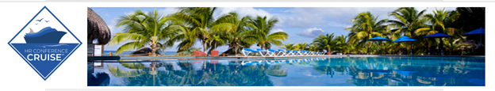
Ready? Tier One Pricing Extended for the Next HR Conference Cruise!

We have extended tier one registration until February 15th!

Join us for the May 21-26, 2022, HR Conference Cruise. We will depart from Port Cape Liberty (near the Newark, NJ Airport) for a five-night sailing on the Adventure of the Seas.
We are thrilled to share with you an outstanding line up of speakers! Our opening keynote speaker is Chuck Gallagher speaking on ethics. Joining Chuck are Jill Kopanis, Ben Eubanks, Jim Smith, Karen Williams, and Mary Gormandy White.
Click HERE for our complete schedule and more information about each speaker.
Earn up to fourteen recertification credits, network with other HR Professionals, learn from outstanding speakers - all on a unique conference venue. New this year is the “Surf and Turf” series. Earn four (4) recertification credits from our weekly webinar series leading up to the May sailing. Then, earn ten (10) additional recertification credits while on board!

Do not delay as the ship is on limited capacity!

FAQ: How does the HR Conference Cruise work?
- BEFORE 2/28/22 - Visit hrcruise.com to secure your spot with a $100 deposit.
- During the transaction we will ask you what kind of stateroom you wish to purchase.
- We will invoice you for the balance based on your stateroom selection.
- Then, get ready for the FOUR pre-conference webinars beginning in April 2022.
- In May 2022 - set sail!

Register before February 15, 2022, to secure your spot at our tier one pricing AND earn $100 in on board credit!
hrcruise.com

Questions? Contact:
Ned Hirt, Past Director, NYS SHRM - nedhirt@gmail.com

Mike Medoro, Aspect Marketing - mgmedoro@aspect-marketing.com

